**Sequence Diagram: Group Post Management**

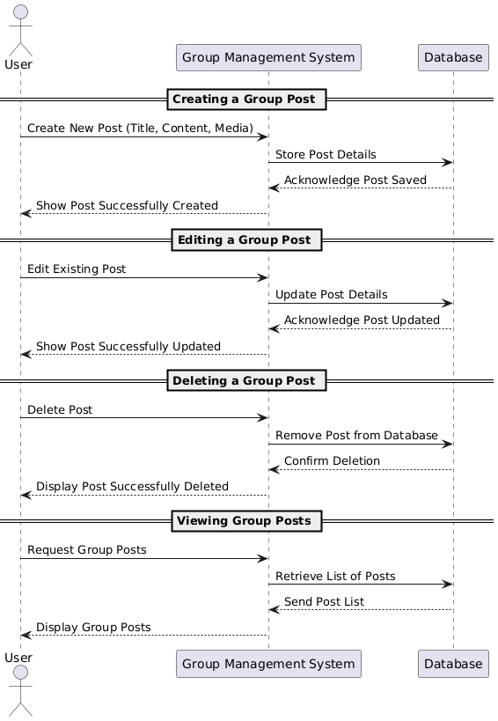

**Database**

**Functional Requirements (FRs)**

* **FR1:** The system shall allow users to create group posts with title, content, and media.
* **FR2:** Users shall be able to edit their own posts**.**
* **FR3:** Users shall be able to delete their posts.
* **FR4:** The system shall allow users to view all posts in a group.
* **FR5**: The system shall store timestamps for post creation and updates.

**Non-Functional Requirements (NFRs)**

* **NFR1**: The system should allow post creation and updates in under 2 seconds.
* **NFR2**: The database must support high concurrency for multiple users.
* **NFR3**: User permissions must be enforced to prevent unauthorized edits or deletions.
* **NFR4**: All media files must be stored securely with size limits.
* **NFR5**: The system must provide real-time updates when new posts are added.